THEORY OF COMPUTATION
1st Midterm Examination — Solved Answers
Based on the supplied question paper | 24 July 2023

Question-wise topic map
Q. No. | Marks | Topic | Subtopic
1 | 7 | Finite Automata | Applications of DFA and NFA
2 | 5 | Deterministic Finite Automata | DFA construction; parity of symbol counts
3 | 5 | Nondeterministic Finite Automata | NFA construction; first symbol reappears
4 | 7 | Automata State Complexity | Exponential DFA–NFA gap; pigeonhole argument

Conventions and assumptions
- A finite automaton is written as M = (Q, Σ, δ, q₀, F), where Q is the finite state set, Σ is the input alphabet, δ is the transition function, q₀ is the start state and F is the set of accepting states.
- For Question 2, the alphabet is explicitly binary: Σ = {0, 1}.
- Question 3 does not specify an alphabet. The worked diagram uses Σ = {0, 1}; the construction is also stated for any finite alphabet Σ.
- Question 4 asks for a bad case in which DFA state count is much larger than NFA state count. The standard family Lₙ = {w ∈ {0,1}* : the nth symbol from the right is 1} demonstrates an exponential gap.

Question 1 | 7 marks
Question: Write any four applications of NFA & DFA.
Topic | Finite Automata
Subtopic | Applications of deterministic and nondeterministic finite automata

Finite automata are mathematical models of systems that read input symbols and change between a finite number of states. DFA and NFA recognize exactly the regular languages. The following are four important applications.

1. Lexical analysis in compilers
A compiler's lexical analyzer (scanner) groups source-code characters into tokens such as identifiers, keywords, numbers and operators. Token patterns are commonly specified using regular expressions and implemented using finite automata. A DFA can scan the input efficiently and determine when a token has been recognized.
Example: an identifier may be described by the pattern [A–Z, a–z][A–Z, a–z, 0–9]*. An automaton checks that the first character is a letter and all following characters are letters or digits.

2. Pattern matching and text searching
Finite automata can search text for a specified pattern. The automaton reads the text from left to right and changes state as it matches successive characters. This is useful in text editors, search utilities and simple string-matching tools.
Example: a pattern such as '101' can be represented by an automaton that enters an accepting state whenever the substring 101 has been found.

3. Regular-expression processing
Regular expressions are used to describe regular languages. They can be converted into NFAs, and an NFA can be converted into an equivalent DFA. This allows software to implement regular-expression matching using finite-state machines.

4. Design and verification of sequential digital circuits
A sequential circuit has a finite set of operating states. Its next state depends on its current state and input. A DFA is a natural model for such a controller, for example a vending-machine controller, traffic-light controller or sequence detector. The state diagram helps designers specify and check the circuit's behavior.

Conclusion
DFA and NFA are useful wherever a system must recognize patterns or operate with a finite set of states. NFAs are often convenient for describing or constructing pattern recognizers, while DFAs are convenient for direct deterministic execution.

Question 2 | 5 marks
Question: Construct a DFA for L = { w | w is a binary string that has an even number of 1s and an even number of 0s }.
Topic | Deterministic Finite Automata (DFA)
Subtopic | DFA construction using parity tracking

We must accept exactly those binary strings in which both counts are even. The DFA therefore records two pieces of information: the parity of the number of 0s read and the parity of the number of 1s read.

1. Define the states
Use the first letter for the parity of 1s and the second letter for the parity of 0s:
- EE: even number of 1s and even number of 0s.
- OE: odd number of 1s and even number of 0s.
- EO: even number of 1s and odd number of 0s.
- OO: odd number of 1s and odd number of 0s.
Initially, no symbols have been read, so both counts are zero (even). Thus EE is the start state and the only accepting state.

2. Formal definition
M = (Q, Σ, δ, q₀, F)
Q = {EE, OE, EO, OO}, Σ = {0, 1}, q₀ = EE, F = {EE}
The transition function toggles only the parity corresponding to the symbol just read:
δ((p₁,p₀), 1) = (¬p₁, p₀) and δ((p₁,p₀), 0) = (p₁, ¬p₀)
Here E changes to O and O changes to E. Reading 1 toggles the parity of 1s; reading 0 toggles the parity of 0s.

3. Transition table
Current state | Input 0 | Input 1
→ *EE | EO | OE
OE | OO | EE
EO | EE | OO
OO | OE | EO
→ denotes the start state and * denotes an accepting state.

4. DFA state diagram
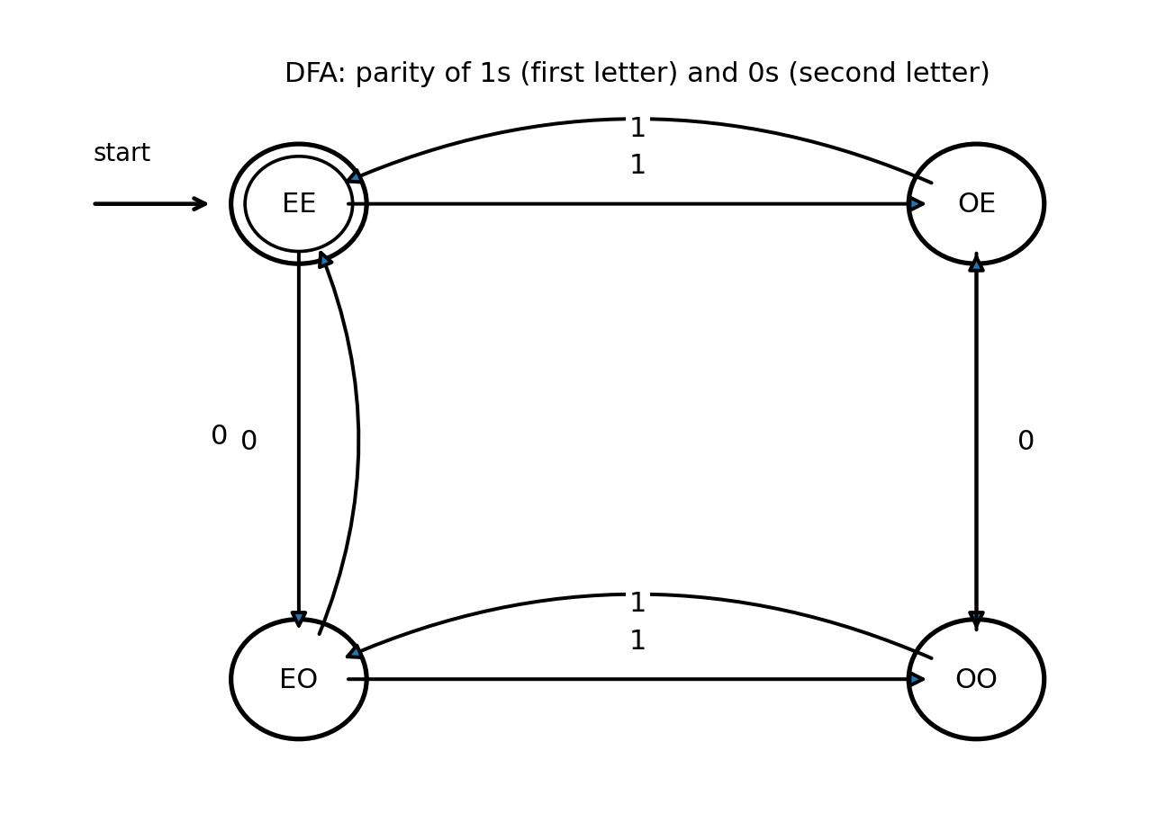

5. Example verification
Take w = 1100. Starting at EE: read 1 → OE; read 1 → EE; read 0 → EO; read 0 → EE. The final state is EE, so 1100 is accepted. It has two 1s and two 0s, both even.
For w = 101, the path is EE → OE → OO → EO. The final state EO is not accepting, so 101 is rejected.

Conclusion
The DFA has four states because there are four possible combinations of the two parities. It accepts if and only if both symbol counts are even.

Question 3 | 5 marks
Question: Construct an NFA for strings where the first symbol is present somewhere later on at least once.
Topic | Nondeterministic Finite Automata (NFA)
Subtopic | NFA construction for a repeated first symbol

Interpretation: a nonempty string is accepted if its first symbol occurs at least one more time somewhere after the first position. The NFA remembers the first symbol and nondeterministically chooses a later occurrence of that same symbol.

1. Formal language
L = { w ∈ Σ⁺ : if w = ax, then a occurs in x }
For the diagram, take Σ = {0,1}. Thus:
L = { w ∈ {0,1}⁺ : the first bit of w appears again later in w }

2. State meanings
- q₀: start state; no input has yet been read.
- p₀: the first symbol was 0; the machine is still searching for a later 0.
- p₁: the first symbol was 1; the machine is still searching for a later 1.
- qf: a matching later occurrence has been found; this is an accepting state.

3. Transition function
The transition function of an NFA returns a set of possible next states, δ : Q × Σ → 2^Q.
Q = {q₀, p₀, p₁, qf}, Σ = {0,1}, start = q₀, F = {qf}
State | Input 0 | Input 1
q₀ | {p₀} | {p₁}
p₀ | {p₀, qf} | {p₀}
p₁ | {p₁} | {p₁, qf}
qf | {qf} | {qf}
The nondeterministic choice occurs in p₀ on input 0 and in p₁ on input 1: the machine may either keep searching or guess that the matching symbol has now appeared.

4. NFA state diagram
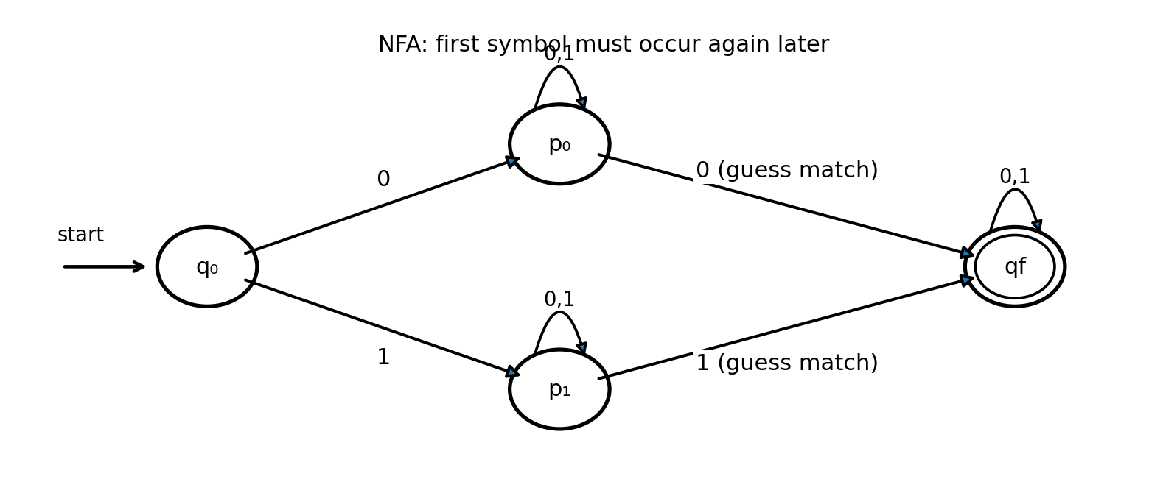
In the diagram, the self-loops on p₀, p₁ and qf are labeled 0,1. From p₀, input 0 can go both to p₀ and qf; from p₁, input 1 can go both to p₁ and qf. The q₀ transitions consume the first symbol and select the corresponding search state.

5. Example verification
Accepted: 010. The first symbol is 0 and it occurs again at the third position. The NFA follows q₀ → p₀ on the first 0, stays in p₀ on 1, and moves to qf on the final 0.
Rejected: 011. The first symbol is 0, but no later 0 occurs. No computation can reach qf, so the string is rejected.

Generalization to any finite alphabet
For each a ∈ Σ, create a search state pₐ. From q₀, on input a, move to pₐ. State pₐ loops on every symbol in Σ, and on input a it also has a transition to qf. State qf loops on every symbol. This accepts exactly when the first symbol appears again later.

Question 4 | 7 marks
Question: Write a bad case where states(DFA) >> states(NFA); describe with pigeonhole principle.
Topic | Automata State Complexity
Subtopic | Exponential gap between NFA and DFA; pigeonhole principle

A standard example is the language of binary strings whose nth symbol from the right is 1. For each positive integer n, define:
Lₙ = { w ∈ {0,1}* : the nth symbol from the right in w is 1 }
This family has an NFA with only n+1 states, but every equivalent DFA needs at least 2ⁿ states. Therefore the DFA can be exponentially larger than the NFA.

1. NFA construction: n+1 states
The NFA reads any prefix in q₀. Whenever it reads a 1, it may nondeterministically guess that this 1 is the required nth symbol from the right. After that guess, it must read exactly n−1 additional symbols and then accept.
Q = {q₀, q₁, …, qₙ}, F = {qₙ}
Transitions:
- δ(q₀,0) = {q₀}; δ(q₀,1) = {q₀,q₁}. The NFA may continue scanning or guess the current 1.
- For 1 ≤ i < n and a ∈ {0,1}: δ(qᵢ,a) = {qᵢ₊₁}.
- There are no outgoing transitions from qₙ. Acceptance occurs only if the input ends just after the NFA has consumed the required n−1 symbols.
The NFA contains q₀ plus n counting states q₁ through qₙ, so it has n+1 states.
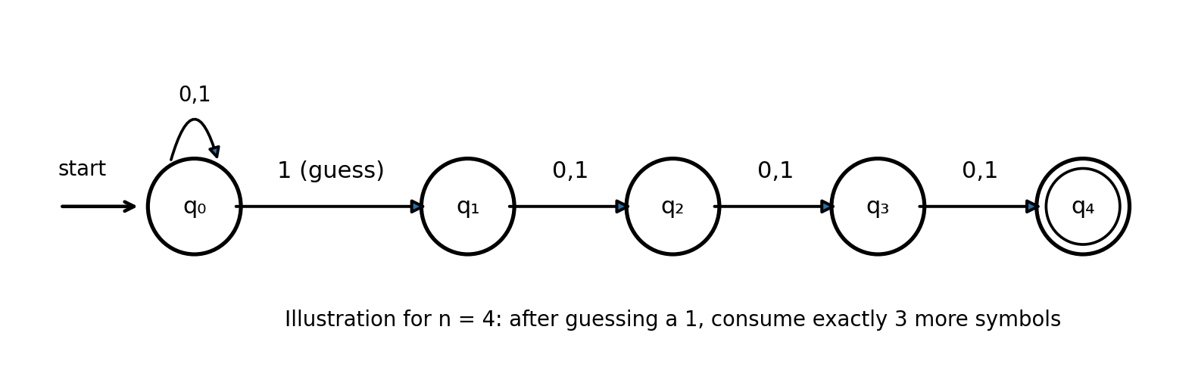
The diagram illustrates n = 4. After guessing a 1, the machine must read exactly three more bits to reach the accepting state q₄.

2. Why a DFA needs at least 2ⁿ states
Consider all 2ⁿ binary strings of length n. A DFA that recognizes Lₙ must be able to distinguish every one of these length-n strings, because different strings can require different future decisions.

3. Pigeonhole-principle argument
- There are exactly 2ⁿ distinct binary strings of length n.
- Suppose, for contradiction, that a DFA recognizing Lₙ has fewer than 2ⁿ states.
- By the pigeonhole principle, two different length-n strings x and y must lead the DFA to the same state after being read.
- Because x ≠ y, they differ at some position j, where 1 ≤ j ≤ n.
- Append the same suffix z = 0ʲ⁻¹ to both strings. In xz and yz, the nth symbol from the right is the jth symbol of the original length-n prefix.
- Since x and y differ at position j, exactly one of xz and yz has 1 as its nth symbol from the right. Thus one string belongs to Lₙ and the other does not.
- But the DFA was in the same state after x and y, and it reads the same suffix z from that state. It must therefore give the same accept/reject result for xz and yz. This is a contradiction.
Therefore, no DFA with fewer than 2ⁿ states can recognize Lₙ. Hence every equivalent DFA has at least 2ⁿ states.

4. State-count comparison
Automaton | Number of states | Growth
NFA | n + 1 | Linear
Equivalent DFA | At least 2ⁿ | Exponential
DFA-to-NFA state ratio ≥ 2ⁿ / (n + 1)

Conclusion
The language Lₙ demonstrates an exponential state-complexity gap: an NFA can recognize it using n+1 states, while any equivalent DFA requires at least 2ⁿ states. The pigeonhole principle proves the lower bound by showing that fewer than 2ⁿ DFA states would force two distinguishable prefixes into the same state.

Exam note: In Question 4, the phrase 'bad case' is interpreted as a family of languages for which determinization causes an exponential increase in the number of states. The proof above supplies the required pigeonhole argument.

